Action Duchenne Champions
Runner training guide

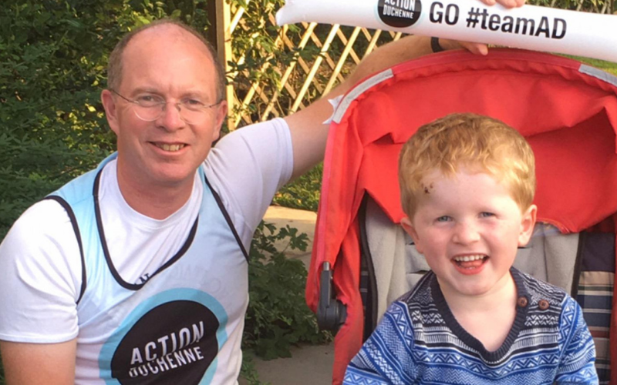

Contents:
Introduction
Training plans
Running kit
Injury prevention
Nutrition
And finally..

Introduction
This guide is for all types of runner, whether you are just starting or experienced with many races under your belt. Running for our small charity is incredibly rewarding, it will boost your physical and mental health and give you a real feeling of contributing towards a better world. We want a world where lives are no longer limited by Duchenne muscular dystrophy, and we are so happy you have joined us to help us achieve this.

Note: The injury prevention and nutrition advice has been written by our Outreach Officer, Alex Berbank, who is a former elite athlete and trained physiotherapist. However, for any sudden lifestyle changes please do consult your GP first.

We are thrilled to have you join our team of Action Duchenne Champions. Each year so many amazing people, like you, take part in a run for us. We want you to enjoy this experience, and to feel supported by us the whole way through.

Firstly, we want to ensure you have picked the right distance and feel excited about the challenge ahead. There are really important questions you need to ask yourself now that will be vital in determining whether or not you make it through to race day. Take some time to assess how things are right now.

- How is your health?
- How busy is your work life schedule?
- What other responsibilities do you have?
- How will you fit training in?
- Do you have any existing niggles or injuries that running could make worse?
- Do you have connections (friends, family, colleagues) who will help you meet your fundraising target?
- Is there anything worrying you in particular?

If there is anything concerning you relating to the questions above, please reach out to us. We want to make sure you feel confident you have picked the right distance and the right race for you. If it’s not the right race, we will help you find another running event or challenge.

It may be that you have no worries or concerns, and you feel excited and confident about your run. This is how we really want you to feel and we are still here to support you with anything that you need.

For support please get in touch with Victoria our Community Fundraising and Support Officer
victoria.young@actionduchenne.org
SMS or Whats App: +44(0) 07946 259850

Running kit

Running shoes

The most important piece of your running kit. You need to consider a few things when investing in a new pair
- SURFACE? Consider the surface you are running on, most races we have places in are on road so investing in a road running shoe is wide. For those doing off-road challenges, looking at trail shoes is a must.
- DISTANCE? Generally for longer distances a shoe with more cushioning is important
- GAIT ANALYSIS? Lots of running stores offer free gait analysis, and they will help you identify the right type of run shoe for you.

Clothing
Look for clothing that is
- Sweat-wicking
- Quick-drying
- breathable - look out for mesh ventilation panels and seamless design
- Consider UV protection for summer running
- avoid cotton
Our Action Duchenne run vests tick the boxes for all of the above!

Underwear

Comfortable underwear is a must have. If you haven’t heard of it before, Runderwear is great,

For women, a well fitting sports bra is really important. Check out Runners Worlds best picks for 2023

Socks

The best socks for running should keep your feet cool and the moisture away from your skin. Go for technical and sweat-wicking fabrics, mesh ventilation under your arch, flat seams and a snug fit.

Training plans

If you have signed up for an event and registered on the official race console, you will receive email communications from the event. This will include training plans. These are often really good quality plans.

We have also searched the web for some of the best training plans.

5k plans
Couch to 5k I NHS

5k training plan I NIKE GB

10k plans
Run Happy and Healthy Plans I London Vitality 10,000

10k training plan I NIKE GB

Half marathon plans
Half marathon training plan I NIKE GB

Half marathon training plan I BUPA UK

Half marathon training programme I Nuffield Health

Marathon plans
Marathon training plan I NIKE GB

Marathon running training plan I BUPA UK

Free marathon training programmes for every goal I Runners World

Other
Return to running programme I NHS

Injury Prevention
Injury prevention is a key part to any training schedule, are some key concepts to live by when training for an event:

- Respect Rest. When it comes to training for running events, quality is always more important than quantity. Even if you find yourself starting your training later than you planned, compressing 10 weeks of training into 4 just doesnt go. Anxiety over being able to complete the goal you set yourself can be overwhelming, but believe me it won't go away because you crammed last minute sessions in. When we train we train in order to make changes to our body, we force our body to make new blood vessels, increase muscle and lose excess timber, all of which only occurs during times of rest.
Training without rest means the body is already fragile and training on a weakened foundation is the easiest way to cause injury. An injury will rule you out for longer than a rest day. During a training plan typically we won't see a reduction in cardiovascular performance until around 8 days of continuous rest. So it's ok to have a weekend off, we promise! Sleep is also a key factor in rebuilding your body and under times of training you need to be having between 7-9 hours of sleep each night. If that number is unobtainable, consider reducing the intensity of your workouts.

- Choose your gear wisely.

“When working in clinics, every year I would see marathon applicants come in complaining of sore feet / ankles / knees back everything. I would say 80-90% of the time this was down to training in incorrect footwear and or wearing medical aids that they don't need.” ~ Alex Berbank, Physiotherapist

Making sure you have the right equipment sounds simple, but it's also making sure you don't have anything you don't need. Footwear is one bit of equipment you want to get right. Everyone's foot is different and so is their running style, so getting the right shoe is all about finding a pair that will compliment you in all the right places and support you where you need it most. If you have the money or time go to a specialist running shop to have an analysis done on your running pattern and get a feel for the right running shoe for you. Normally these assessments are free when you buy a pair of shoes from the shop, but won't cost more than £20 and then you can search online to find the correct shoes cheaper. If this isn't an option, invest whatever you have into the best feeling shoe. Always test them out first in person before committing to buying them, and don't be fooled by brand or price, some of the best running shoes are often from a brand you haven't heard of and half the price of the others. Secondly, get rid of those running aids you don't need. There are alot of companies that specialise in convincing people they need joint supports or stretchy tape or any piece of tat that has the word ‘orthopaedic or ergonomic’ and whilst a few of these products can be useful is some instances the vast majority of them will only exacerbate the issue or at best provide a placebo effect. Unless you have a chronic or very recent injury, always train with as few of these supports as you can. Our bodies have evolved to be exceptional long distance athletes and although initially there may be an uncomfortable start your body will adapt to the training plan as long as its given rest and time to do so. If you're concerned about a previous injury or chronic condition, book in to see a qualified Physiotherapist to get their opinion on the best course of action.

- Adapt to an injury, don't ignore it. We know how frustrating it is to pick up a knock! The worst thing you can do is try and be a ‘warrior’ and train through it, it won't get better and it will only get worse. Equally sitting at home when you want to be active is also frustrating. The best thing you can do is find a way to train that won't aggravate the injury. Working on balance core strength and individual muscle strength will all improve an athlete's ability to train and run further / faster. For example, if your left knee picks up a twinge or something doesn't feel right, instead of running 5km, can you walk it instead? Or maybe take up some yoga sessions, some strength sessions that focus on the right leg mainly or core. All of this will help the body make adaptations you will need to run further and faster without actually running. Ignoring the injury will only make your body more determined to stop you ignoring it by increasing the pain or limiting the movement.

- No such thing as bed rest. Ok this sounds different to all the rest so let me explain this. This is specifically for when you have picked up an injury. A lot of injuries result in swelling of joints of specific places in a muscle, the best thing for this situation is to keep the area moving with gentle patterns and movements. This will increase blood flow to the area and aid the body to reduce the swelling itself. In the case of most joints it also allows the body to lubricate the joint and maintain its health. This works far better than any other massage or medical gimmick. Often you feel these injuries before you can see them, listen to your body, catch it early and it may not impact your training schedule at all, but if you leave it and ignore it you’ll only ever come to regret it. Again if in doubt consult your local registered physiotherapist for advice.

It is always upsetting when one of our runners has to pull out due to injury. So making sure you are listening to your body and not ignoring any pains during your training is absolutely vital.

We hope you have an injury free journey with us, but if you do experience any pain or discomfort it’s important you take the time to address it rather than pushing on with your training plan.

Further reading
Running Injuries Top Tips For Preventing Running Injuries by Phil Mack
Physio Running Injuries

Nutrition
What you eat while you train is really important for overall health and performance. Nutrition can be a difficult subject to approach especially if you’re new to sports nutrition. There's a lot of talk about macros and supplements and diet plans. No doubt it's overwhelming but it doesnt need to be. The concept you need to bear in mind during this is that whatever plan you decide to do needs to be something you can fit into your life. Often it's not about what you eat but when you eat, with consistency being key, trying a new diet every few weeks rarely leads to the desired outcomes you set at the beginning of your plan.

You may well enjoy the science of measuring out the exact grams of protein and carbs in each meal as well as taking the additional vitamins and if this sounds like you then look for articles from qualified dietitians, find one that you like the look of and can see yourself sticking to. If it isn't then look at when you're currently intaking, if you feel the need to change try and work out what you want to change about the diet and a new way to fit it in.

Often with people new to running it's a case of decreasing carbs and increasing protein and vegetables. We have an inbuilt craving for calories which is why so many of our comfort foods have a complex carb base, such as potatoes or bread, and when we feel tired we reach for sugary sweet things like chocolate or sweets. Making changes like using wholemeal rice, bread or pasta and swapping sweets for juicy fruits can often reap the same rewards

Further reading
BBC Good Food website.
What to eat on rest days or light intensity days
What to eat on normal training days (moderate intensity)
What to eat on heavy training days
What to eat on race day

And finally….

Good luck.

We wish you the very best with your training and on the day!

