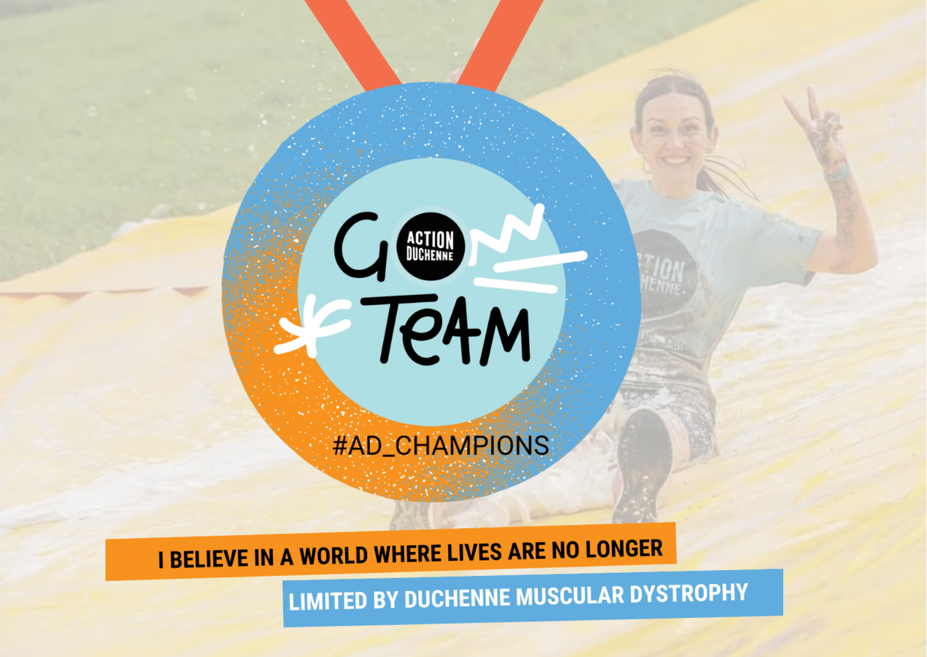
Action Duchenne Challenges Brochure

“If you have a challenge that you want to take on - take it on. My challenge quickly became something bigger and infinitely better because I wanted to involve Action Duchenne in it.”

Fundraising and raising awareness for Action Duchenne will give you the opportunity to try new things, make meaningful memories, tackle challenges and get to know our amazing community of supporters. It also will give you more of an insight into who we are and what we do. We are so passionate about the work that we do, and having you be part of it with us means a lot.

As a small charity, our event calendar offers a few key events that you can take part in for us each year to help raise funds. But, that’s just the tip of the iceberg, we can also get places for individuals and groups in a variety of challenges. Our events are also a perfect way to raise a company’s profile and provide a great way to build a strong team.

Why not take a look at just some of the ways you can support our life changing work? Or if you have your own idea for a fundraising event get in touch and we’ll make it happen!

✉️

fundraising@actionduchenne.org

10ks and Half Marathons
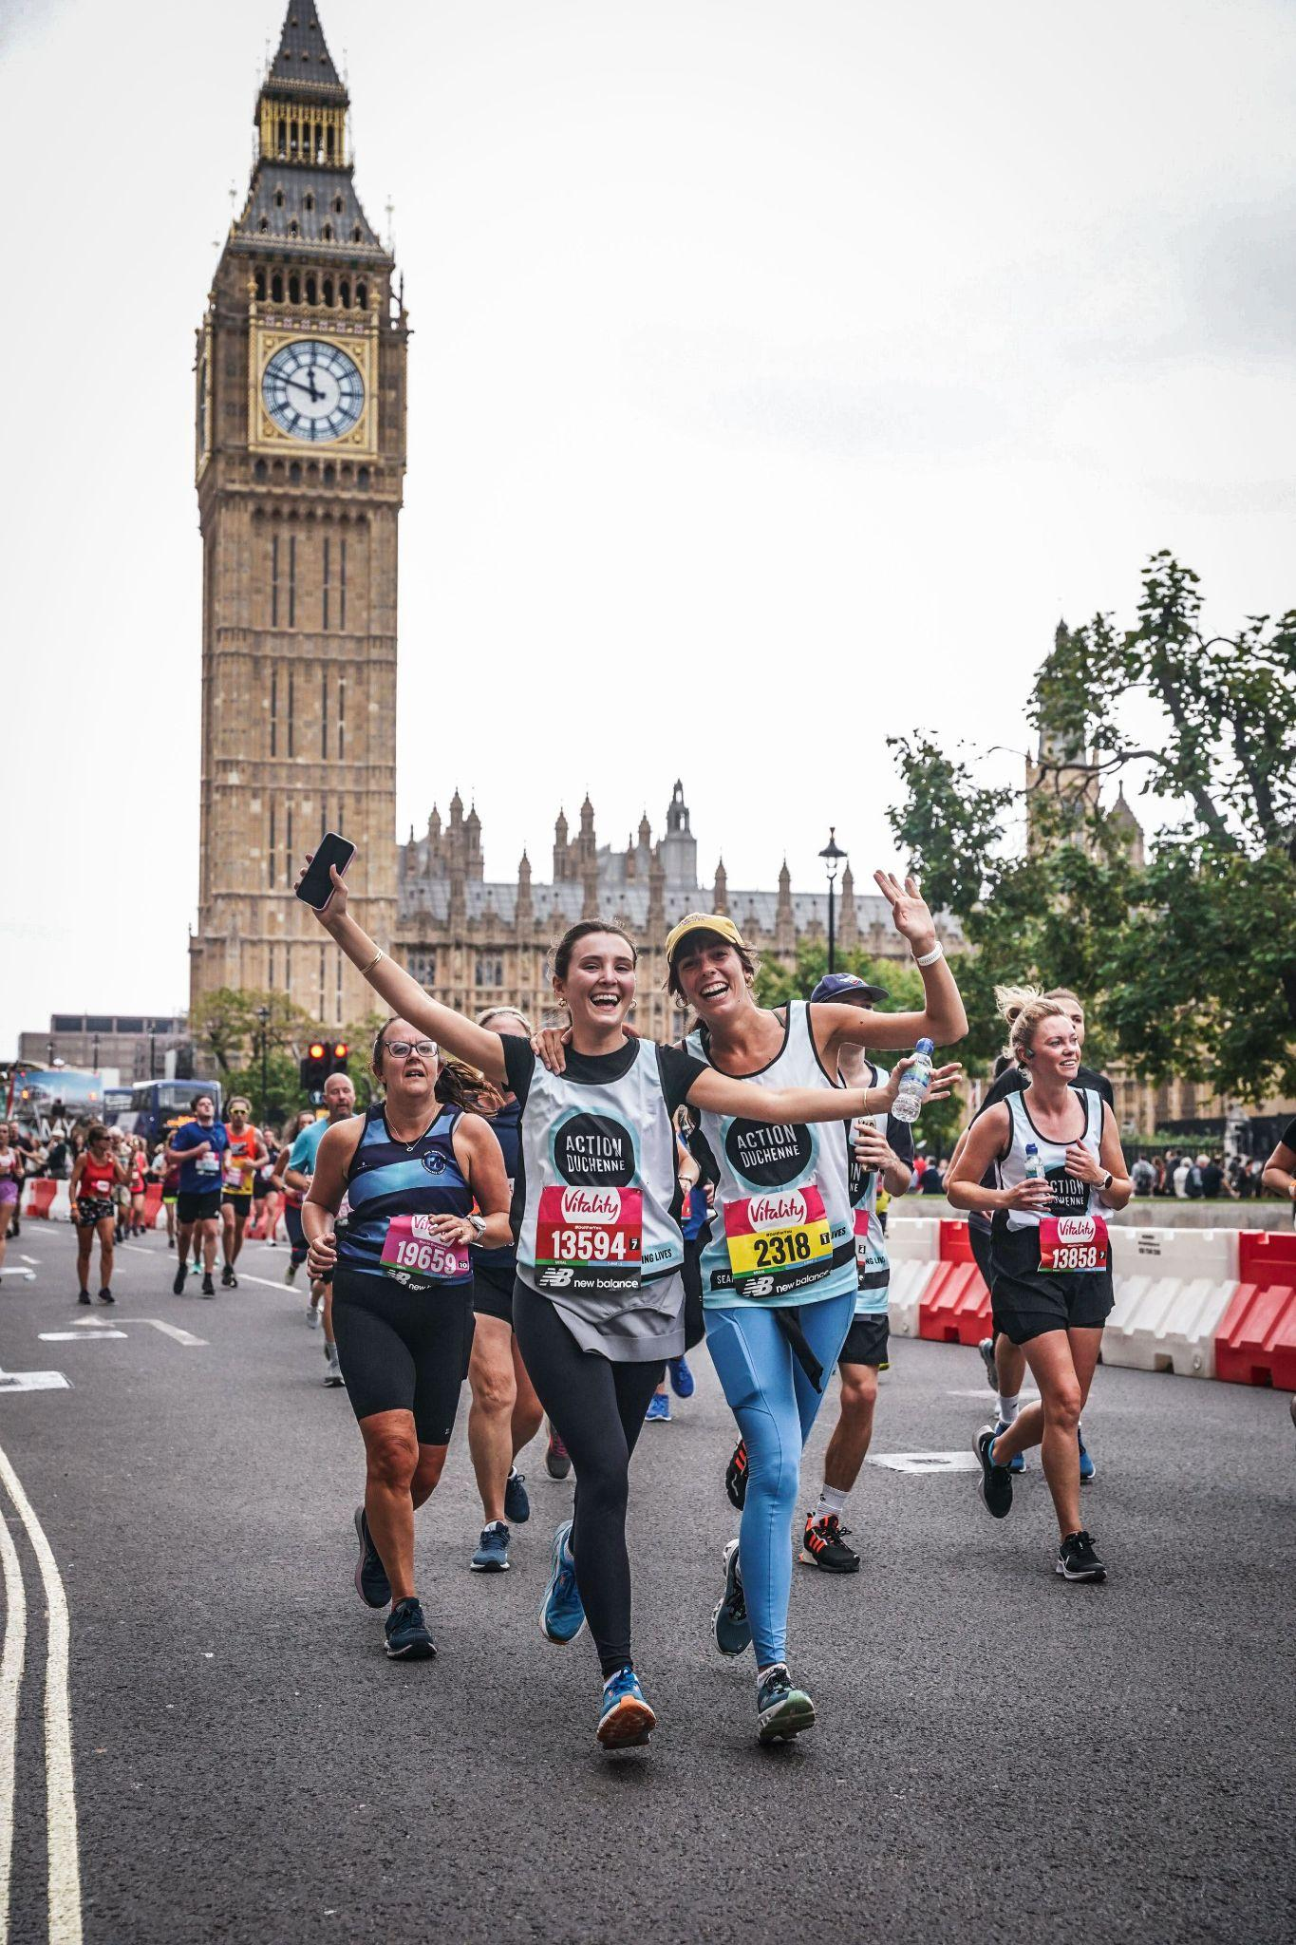 | As a runner, each step you take helps us to achieve our vision of a world where lives are no longer limited by Duchenne. By wearing our run vest, you are making a difference to many lives as you run past thousands of people who are likely to not have heard of Duchenne before.  Feel the rush of running past famous landmarks, the satisfaction of a seaside finish, the fun of posing with mascots on route, and the all round amazing atmosphere from an organised run. Plus, who doesn’t love a medal?!  Across the world there are a variety of 10km and Half Marathon races to enter.  Some great ones to consider…  London Vitality 10km - London Winter Run - Brighton 10km - Great Manchester Run - Great North 10km - Great Scottish Run - Swansea Bay 10km - Cardiff Half Marathon - Oxford Half Marathon - The Big Half - Hackney Half Marathon

Marathons
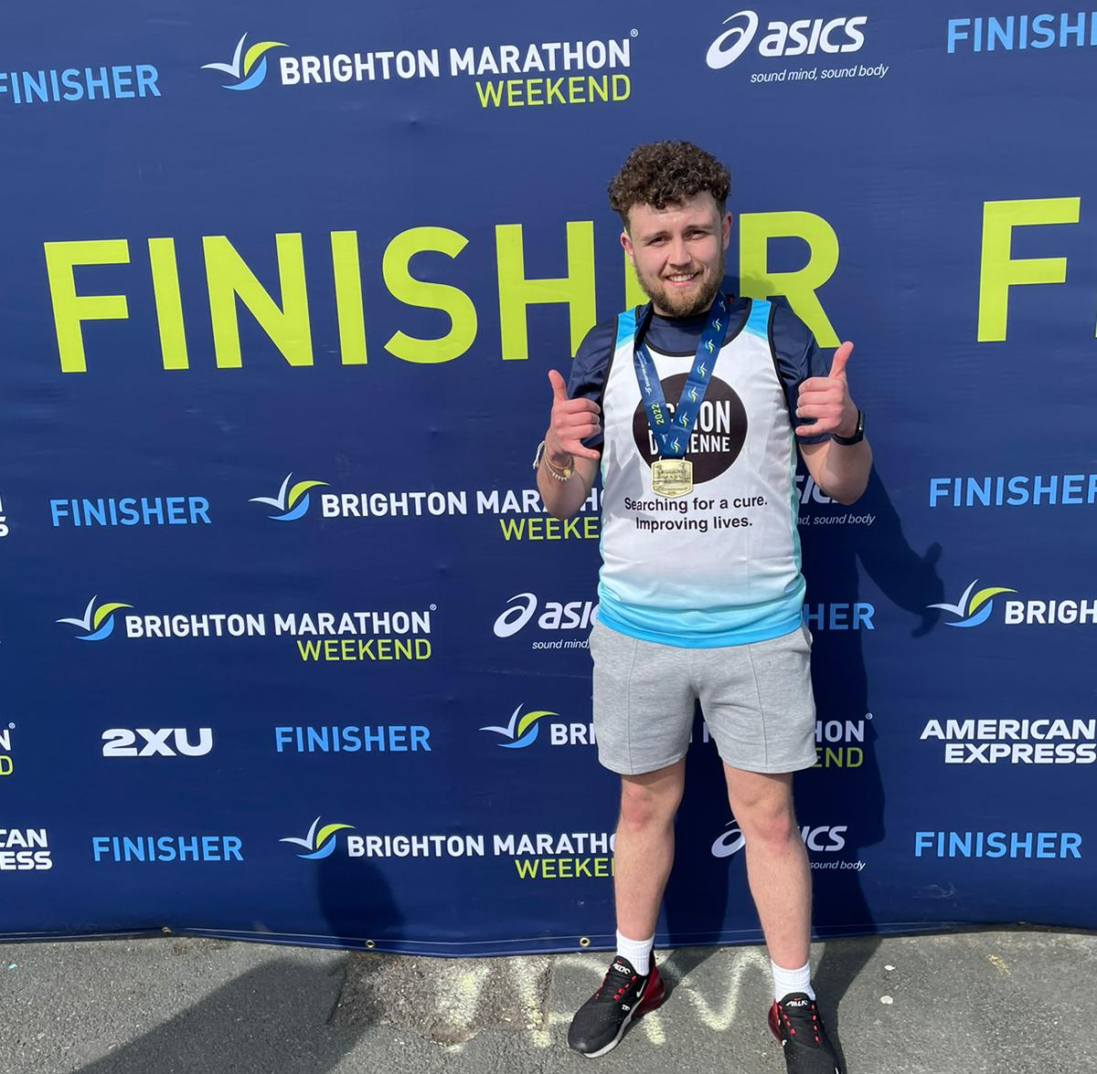 | When you first heard about Duchenne, did you know what it was? It’s likely your answer is no.  Duchenne is a rare condition, affecting approximately 1 in 3,500 male births in the world. By running a marathon for us, you not only become part of a rare 0.01% club of the world's population who run marathons but you also are raising the profile of a little known cause. We salute you!  There is nothing like a race day of a marathon and across the world there are a variety to enter.  Brighton Marathon - Manchester Marathon - Edinburgh Marathon - Loch Ness Marathon - Dublin Marathon - Paris Marathon - Berlin Marathon - New York City Marathon

Ultra Challenges
If you have ever met someone living with Duchenne, you will know that they have determination like no one else you have ever met. So, when a marathon is simply not enough of a challenge for you to take on for them, there are few people who dare to go further.

Escape from the ordinary, go through every emotion (even ones you just weren’t aware you had) and push your body and mind to its limits. Do an Ultra marathon!

London 2 Brighton - Isle of Wight Ultra - Jurassic Coast Ultra - Lake District Ultra - North Downs Ultra - Thames Path Challenge - Ironman - Race to the Stones

Cycling challenges
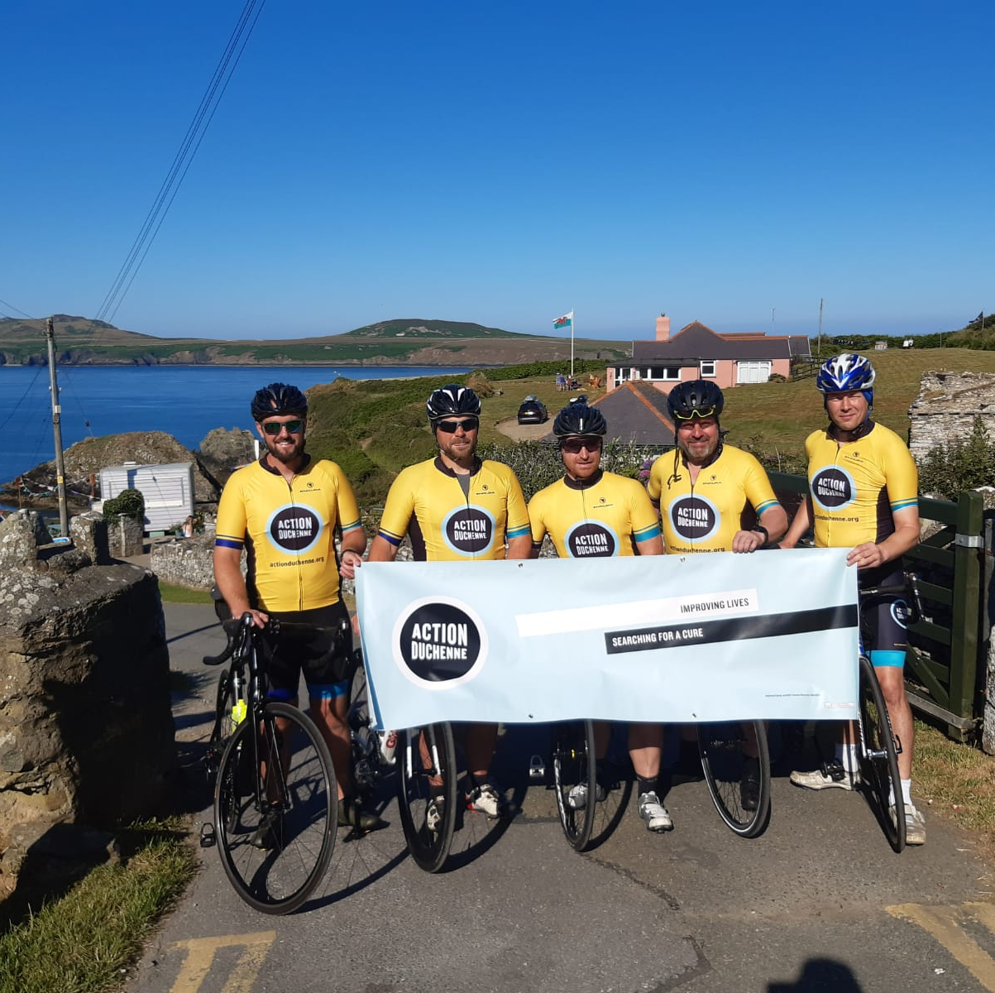 | At Action Duchenne, we are all about the wheels! Wheels often mean a sense of independence, enjoying the great outdoors and the ability to get places quicker.  You may have been out of the saddle a little while, or you could be a cycling fanatic. Taking part in an organised cycle, or planning your own, is a wonderful way to support us.  Across the UK and Ireland there are a variety of cycling challenges to enter.  Ride London - London to Brighton - Palace to Palace - London to Paris - Mallorca 312 - Coast to Coast UK  Or you can create your own challenge inspired by routes such as the North Coast 500 or the Three Peaks…

Treks and adventures
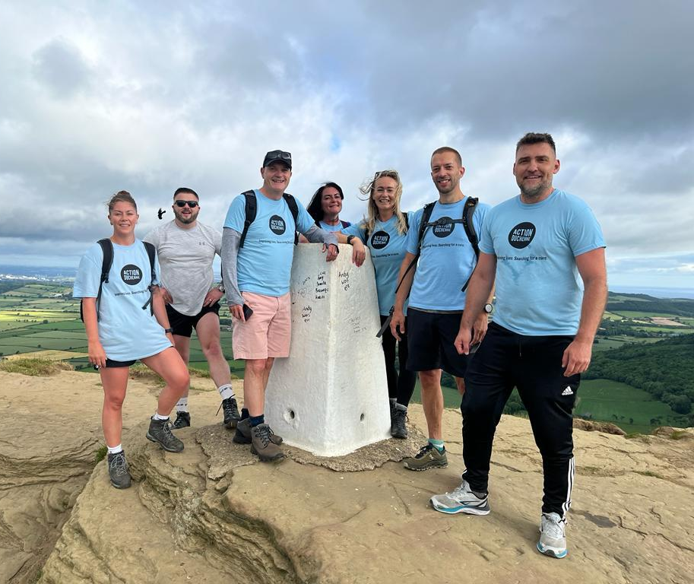 | Help us to take our charity to great heights by scaling tough terrain and managing wild weather conditions. This is an opportunity to embrace all of the elements and get away from the hustle and bustle of everyday life, and really focus on why supporting people living with Duchenne is important.  This is also a great way to tick some things off your bucket list! So many adventures await…  Kilimanjaro - Snowdon - Ben Nevis - Scafell Pike - Mont Blanc - Yorkshire 3 peaks - Hadrians Wall - Sahara Trek - Zipline - Abseil

Obstacle courses, mud runs and fire & ice
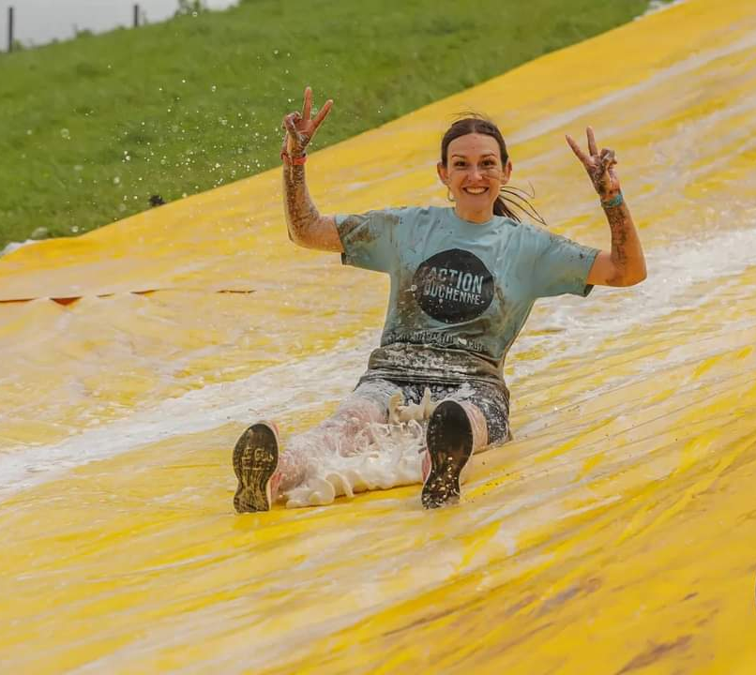 | Become an Action Duchenne warrior and take on the outrageous. You’ll need tons of determination, stamina, grit and love to laugh…or cry….and enjoy comparing your bruises to others! Time to put that bottle of Vanish to the test…  Tough Mudder - The Wolf Run - Mud Girl Run - Spartan Races - Gelt Gladiator - MacTuff Challenges - Colour Runs - Inflatable 5ks - Superhuman Games - Fire walk - Ice/Cold water dip  Find out more

Sky Dive and Wing Walking
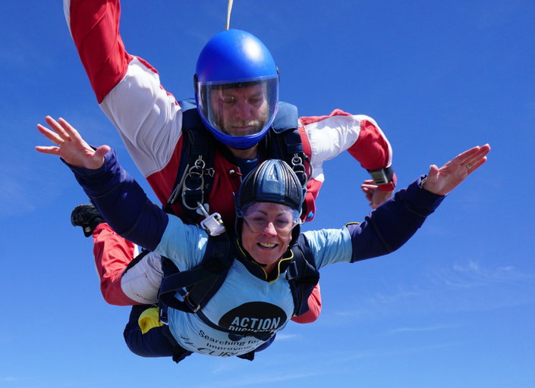 | A lot of Duchenne family members we support often have a lot on their minds, and stress levels can be high. Those who have taken to the skies for us say it’s been a way for them to forget about their troubles for a while. These experiences are unique. The initial pure adrenaline and clarity of the mind as you float or fly through the air and all of the amazing emotions that come on landing.  Go Skydiving  Go Wing Walking
g

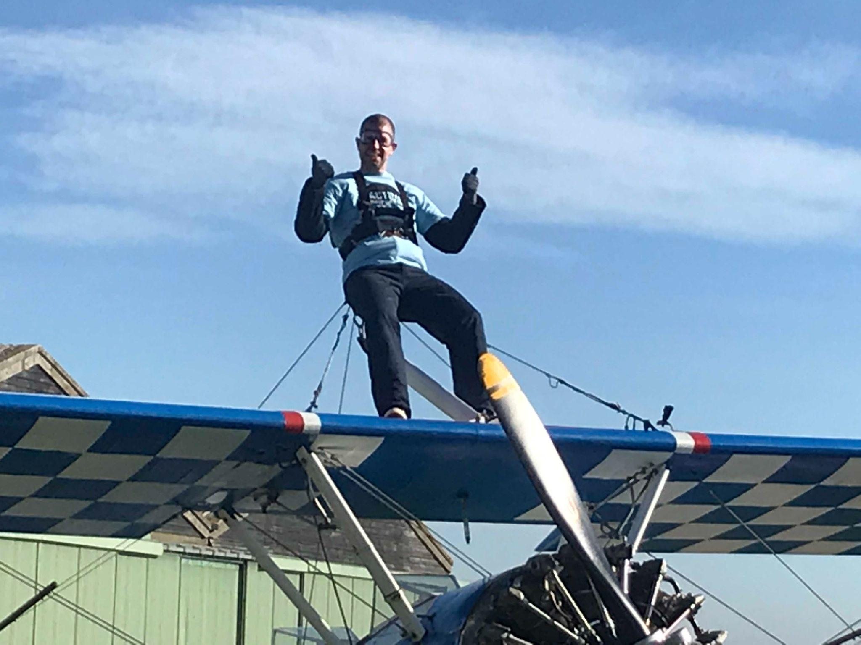

“It is amazing to be part of the Action Duchenne community, to have the option of doing incredible things which I would not do in normal life, but when I was descending 10,000 feet to the ground, the reality stung me emotionally and I was struck again by the main reason I was doing this, my son.”

✉️

fundraising@actionduchenne.org

