Action Duchenne Champions Guide

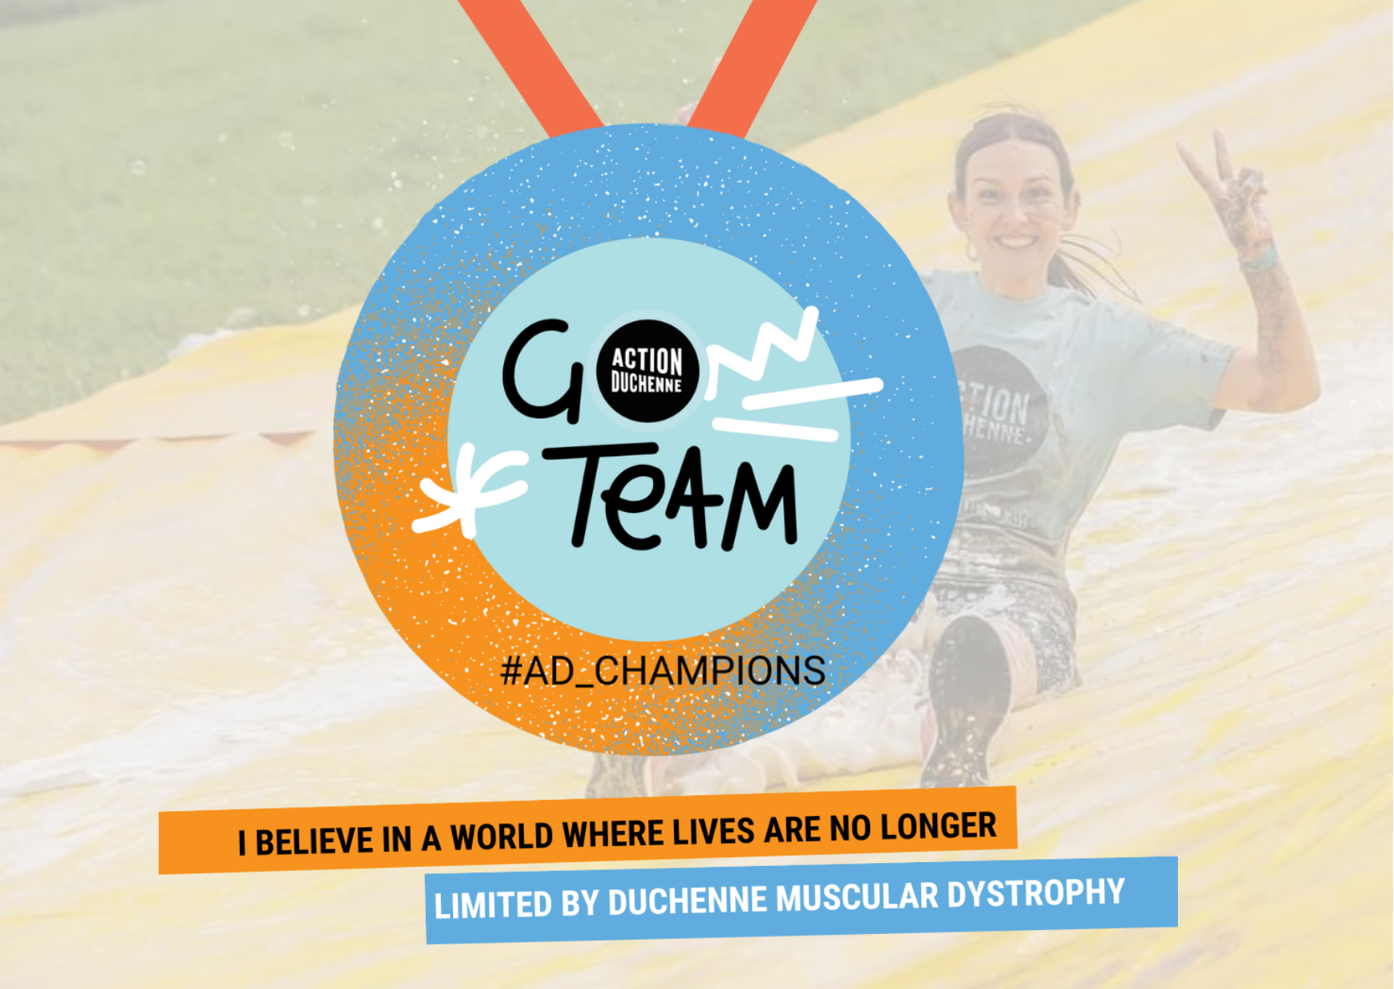

Welcome
Setting up your fundraising page
Employer Support & Match funding
In-person fundraising ideas
Social media
Fundraising email template
We are here to help
Sponsorship and Gift Aid Declaration

Welcome to our team of champions

Thank you for choosing to support Action Duchenne. We like to call those who support us by a name they well and truly deserve…champions!

As an #AD_Champion you are directly helping us to make sure that lives are no longer limited by Duchenne muscular dystrophy. Whether you are taking on a run, a challenge event or organising one of your own fundraising events for us you are a champion for our most worthy cause.

Setting up your fundraising page

The easiest way to receive donations is through setting up an online fundraising page.

When you registered you may have had a fundraising page set up automatically for you, if not you can choose either one of these platforms to create yours

Enthuse

Just Giving

To help you make the most of your page we have put together some tried, tested and proven tips to help you smash your target and have fun.

- Add a profile picture

- Your personal story - tell people who you are and talk about your ‘Why’
- Tell the story of why you got involved and decided to support us (“I am supporting Action Duchenne because…”)
- Be authentic with your story telling. This will resonate with your friends, family and connections (“Please join me in supporting Action Duchenne because…”)
- Add photos that include smiles and update your page regularly with stories and videos of your training.
- Tell people what Duchenne is
“Duchenne muscular dystrophy (DMD) is a rare genetic muscle wasting condition affecting around 2,500 people in the UK – the vast majority being male. The body does not produce a protein called dystrophin which is needed for muscle function. Usually diagnosed around the age of 4 years, parents are told the devastating news that the life expectancy of their child is around 30 years – the worst news you could ever expect to hear. DMD severely affects quality of life; in time, a wheelchair is used full-time and eventually all of the muscles in the body stop working. Ventilation is needed to assist with breathing and death usually occurs from heart failure. There are currently no cures or treatment options available to the entire population who have the condition – this is what Action Duchenne is working hard to change. Established in 2001, Action Duchenne work tirelessly to deliver the overall vision of the charity - 'a world where lives are no longer limited by Duchenne muscular dystrophy.”

3) Tell people who we are
“Action Duchenne has a clear vision: a world where lives are no longer limited by Duchenne muscular dystrophy. We work to deliver their vision through three core objectives:
1) DEVELOPING EFFECTIVE TREATMENTS FOR ALL by funding research, educating clinicians and researchers, supporting clinical trials and campaigning for access.
2) BUILDING A COMMUNITY by supporting and uniting families, educating about Duchenne and raising the profile of the condition to a wider audience.
3) STRIVING FOR A MORE INCLUSIVE SOCIETY by promoting the importance of human equality, day-to-day acceptance of disability and accessibility for those with Duchenne.”
4) Tell them about our impact
‘Each year the Action Duchenne support team are personally supporting over 1,000 families, all of which have benefitted from our expertise, understanding, practical help and empathy. These families gain hope, knowledge and power to help them navigate their Duchenne journey.’

‘Our work to date has seen over £10m invested in ground-breaking research, educational programmes and campaigns.’

‘We have now been delivering our life changing ‘All Through Support’ programme for 2 years. We have had support contacts with 1625 families, supported 82 Newly Diagnosed families, run 40 group support meetings, supported 64 young people living with Duchenne aged 14-25, launched a free group counselling programme and ran 25 Science Education workshops.’

‘Our award-nominated ‘Riley’s Film’ film is vital to spreading awareness about Duchenne muscular dystrophy and Action Duchenne.’
6) Have a fundraising target
7) Social sharing
Share your page everywhere..Facebook, Instagram, Twitter, Linked In and ask people to reshare it! Ask your donors to share your page on their social media when they donate, “I have proudly supported John Smith as he’s running 100 miles over 1 week for Action Duchenne. Please join me”
Social sharing increases your chance of success, you can also email people by using our email template within this guide.
8) Update your page
Let your supporters know how the training or preparing for the event is going. Updates and progress show people how invested you are in what you are doing and shows supporters how hard you are working.
If you are doing a run, walk, swim or cycle you can also connect Strava with your fundraising page!
9) Get people invested in your journey
- Track your steps, miles, hours, minutes etc. This allows your donors to pledge to an activity rather than a flat donation. E.g. ‘For my training and the marathon itself I aim on completing X miles in total’
- Set mini goals or offer prizes, or offer incentives with milestones. For example you could make a promise to donate more of your personal funds for reaching 50 miles, or the donor who helps you reach £1000 milestone gets a prize.
- You could also offer your skills in return for a donation. If you are a hairdresser, offer haircuts. If you are a beauty therapist, offer mani-pedis, facials, massages. If you are a trained fitness instructor - organise a class where all or part of the fee goes to charity. If you are good at maths, english, science, languages why not offer tuition? You could even simply offer to get a group of people together to pack people’s bags in a supermarket.

10) Capitalise on event day

If you are doing an organised event, like a run, then 10% of your total donations will be given on 8am-9am on the big day. So get sharing your fundraising page at this time to boost those donations!
11) Donate to your own campaign
So simple! Those who self donate always raise more than those who don’t. Put aside your spare pennies into a jar, or forgo a take away coffee once a week and put money aside - it all adds up!

Employer Support & Match funding
You can double the amount you raise from your own fundraising efforts when using match funding. Match funding is the ability to secure additional donations from your workplace, grant maker or philanthropist. Ask your company to see if they offer match funding as part of corporate social responsibility.

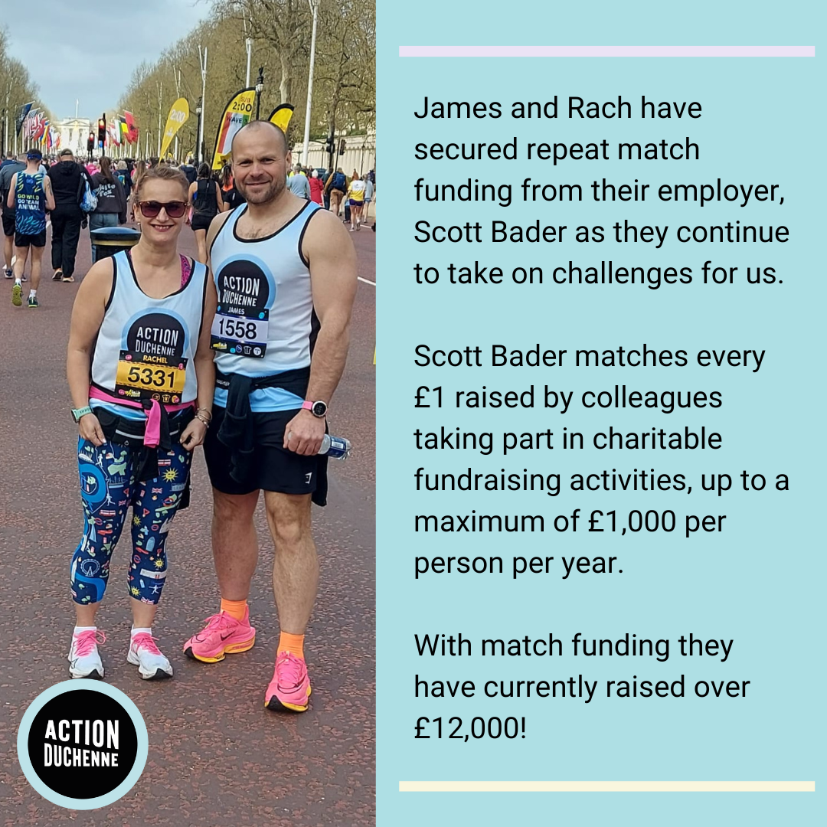 | 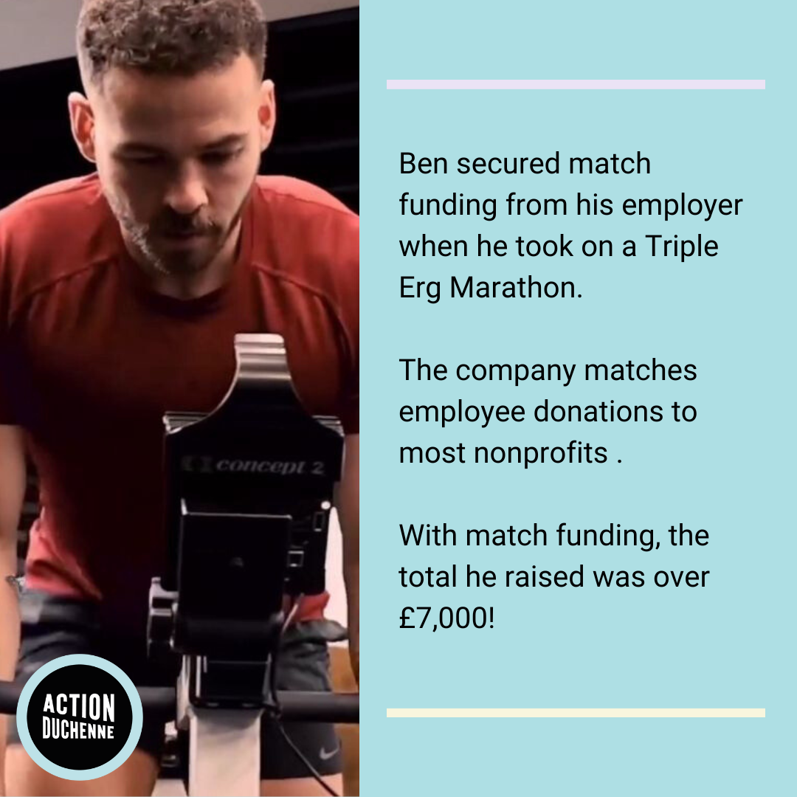
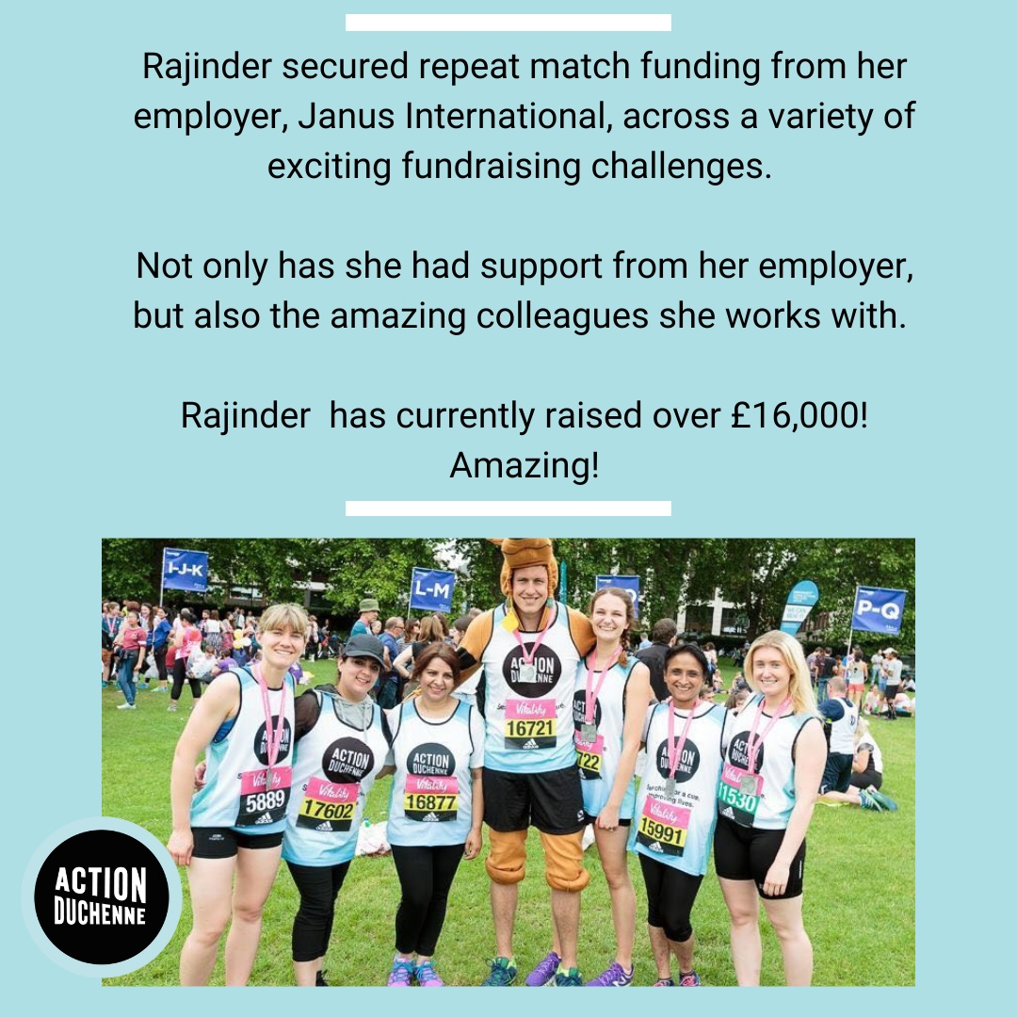

In-person fundraiser ideas

To boost your fundraising try these few tried and tested favourites. See our Fundraising Ideas A-Z.

If you are organising your own fundraising event we love this guide from Eventbrite 10 easy steps for planning a unique charity event

Social media
Share your page with your family, friends, colleagues and encourage them to share and shout about what you are doing too. Remind people what you’re doing and how hard you’re working to invest in our cause!
Suggested posts
I’m supporting everyone living with Duchenne muscular dystrophy by taking on CHALLENGE/EVENT NAME for @ActionDuchenne. Along with funding research for better treatments and searching for a cure this life changing charity provides families and individuals living with Duchenne with much needed support. Will you join me in creating a world where lives are no longer limited by this condition?
Help me to raise much needed funds for @ActionDuchenne. Their vision to improve lives and searching for a cure for everyone living with Duchenne muscular dystrophy is really important to me because INSERT.

Fundraising email template
Personalise the template below as you wish and send to those you feel most comfortable sending it to.
Email subject:
Please help me hit my target for Action Duchenne
Email content:
Hi/Hello/Dear [insert recipient name here],
To help raise money for Action Duchenne, I will be lacing up my trainers and taking part in [insert event type here e.g. Royal Parks Half] on [insert event date here].
Action Duchenne is a charity that is incredibly close to my heart because [personalise your reasons for supporting us here]. Along with funding research for better treatments and searching for a cure this life changing charity provides families and individuals living with Duchenne with much needed support.
I have a fundraising target of [insert fundraising target here] and I would be so grateful for your help to reach my goal. Every penny counts!
The easiest way to donate is through my fundraising page here: [insert page link here]
If you’re not in a position to donate then if you are able to kindly share my fundraising page with others instead, that would also be fantastic.
Thank you so much for your support!
[Insert your name here]

We are here to help

We will always keep in regular contact with you, but please still reach out to us for anything you need or if you just need to chat about how things are going.
Victoria  07946 259850 victoria.young@actionduchenne.org | 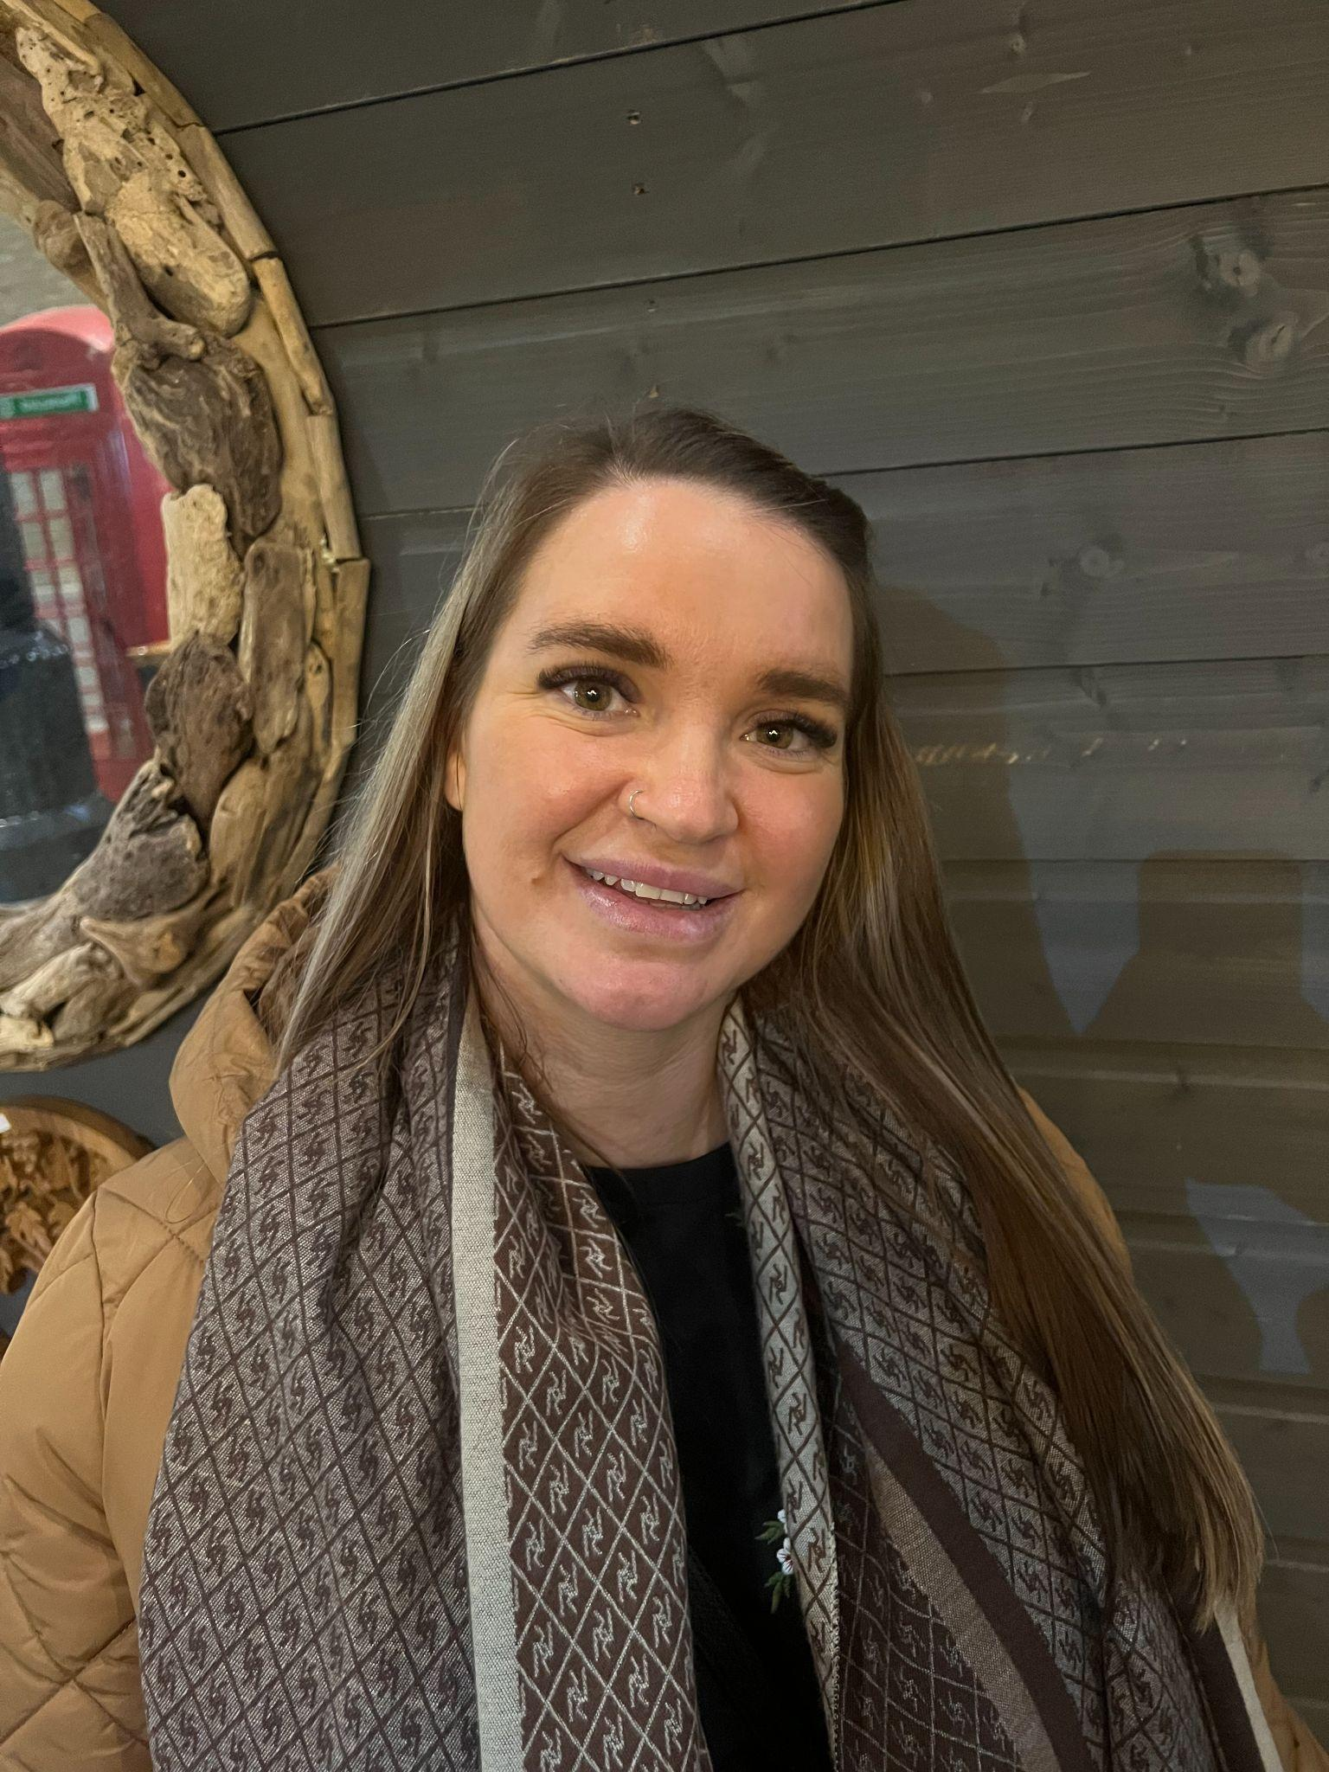  Dawn  07944268186  dawn@actionduchenne.org
Thank you for your support!

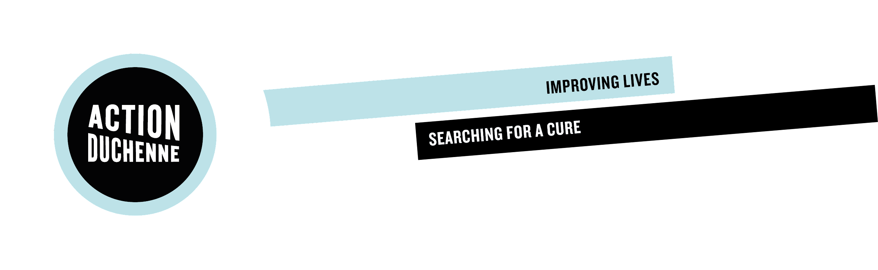

Sponsorship and Gift Aid declaration form
Please sponsor me (name) _____________________________________________________
To (event) _______________________________________________________________________
In aid of Action Duchenne
What is Duchenne Muscular Dystrophy?

- Duchenne muscular dystrophy is a rare genetic condition caused by mutations in the dystrophin gene, which prevent production of a vital muscle protein called dystrophin.
- The lack of dystrophin makes muscles more susceptible to damage and leads to muscle wasting over time. People living with Duchenne muscular dystrophy experience progressive muscle weakness and typically need to use a powered wheelchair from their early teens.
- The heart and breathing muscles are eventually affected and most will require a ventilator in their twenties; life expectancy is around 30 years but has improved with palliative care developments.
- There is no cure.
How Action Duchenne helps
Our work to date has seen over £10m invested in ground-breaking research, educational programmes for those living with Duchenne and campaigns focusing on access to new treatments and improved care. We recognise that whilst science is being funded and therapeutic approaches explored, there are many people that the current approaches may be unable to help. As a charity for everybody living with Duchenne, we must also support those individuals and their families until scientific breakthroughs provide treatments or cures.
Our vision is very clear
At Action Duchenne we have a clear vision: a world where lives are no longer limited by Duchenne muscular dystrophy. We are working to deliver the vision through our three core objectives:
- Developing effective treatments for all by funding research, educating clinicians and researchers, supporting clinical trials and campaigning for access.
- Building a community by uniting families, educating about Duchenne and raising the profile of the condition to a wider audience.
- Striving for a more inclusive society by promoting the importance of human equality, day-to-day acceptance of disability and accessibility for those with Duchenne

Full name  (First name and surname) | Home address  (Only required if you are able to ‘Gift Aid’ your  donation. Please don’t put your work address here) | Postcode | Amount | Date paid | Gift  Aid? *  √

Total donations received | £
Total Gift Aid donations | £
Date donations given to Charity

*“If I have ticked the box headed ‘Gift Aid? √’, I confirm that I am a UK Income or Capital Gains taxpayer. I have read this statement and want the charity named above to reclaim tax on the donation detailed below, given on the date shown. I understand that I must pay an amount of Income Tax and/or Capital Gains Tax in the tax year at least equal to the amount of tax that all the charities and CASCs I donate to, will reclaim on my gifts for that tax year. I understand that other taxes such as VAT and Council Tax do not qualify. I understand the charity will reclaim 25p of tax on every £1 that I have given.”

Please note that the data collected on this form will be securely held on Action Duchenne’s database and will be held securely in line with current data protection legislation. Find out more about how we use your information at actionduchenne.org/privacy-policy

